Selma - a Volunteers Perspective

Sziasztók! My name is Selma. I did my volunteer service in 2014/2015 in Marosvásárhely (Targu Mures) . I started to work at Philothea Club and Dorcas House and added visitations at TBPrevention Center in January 2015 twice a week. In cooperation with Kati I organised different activities including games in English or a trip into the nature with BBQ including sport activities. To meet the parents of the children and see their environment was one the most impressive experiences in my life. My volunteer service is almost three years ago but I am still thinking about my work and the children. Currently I am studying culture studies and political science at Leuphana University in Lüneburg, Germany but I hope to get as soon as possible back to Romania.

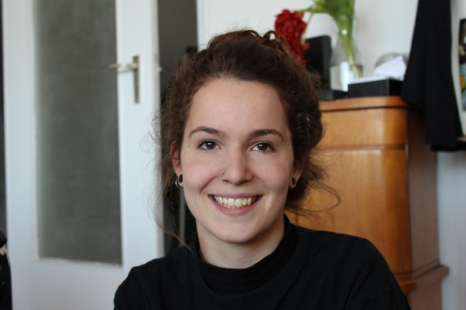
Selma Böhmelmann

