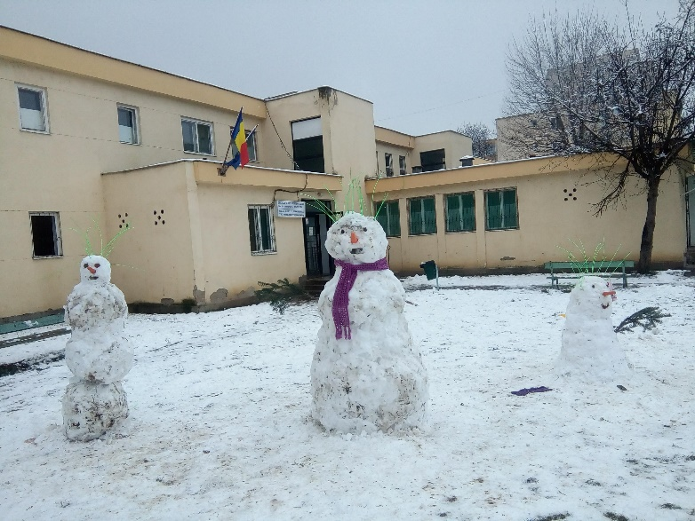
Information for HANNAH Newsletter March 2018

The children at the institution had fun in the snow.

Good News! A time to celebrate!
Since out last Newsletter, we have celebrated Christmas, we are well into the New Year and are now in the season of Lent leading up to Easter. Our lives go through seasons too. Ecclesiastes 3:1,4 “There is a time for everything and a season for every activity under heaven…a time to weep and a time to laugh, a time to mourn and a time to dance.”
This is also true with the work of HANNAH and so it is with much joy that we share the following stories with you…
A New Hope and Future
After much praying and advocating, one of our teenagers has been placed in Dorcas House, a children’s home under Christian Endeavour, giving her the opportunity for a new hope and future. Hallelujah!
Abandoned at birth, and without identity papers, this girl moved from one institution to another. With no identity she was unable to receive a formal education outside of the institutions. Over the past 1 ½ years her identity was established. Dorcas House, who already knew her, applied for her to become part of their family, and recently the Court granted this request. She was welcomed warmly into this home in February this year.
We praise God for working in such miraculous ways, making the impossible possible. Please keep praying for this girl as she learns to live in the community, making her own decisions, taking responsibility, trusting others, accepting God’s love and the love of those around her who care deeply for her.
Gabi’s Roma (Gypsy) family
Gabi’s house has been able to be kept warm this winter thanks to the renovations and dry firewood supplied by ‘Winter Help’ from Holland plus some extra wood. We very nearly got through the winter without Gabi’s mother going to hospital but just in the last two weeks she became very ill with a flu virus that is going through Europe, and from which people are dying in Romania. Kati has helped sort medicines and brought food and there has been a slight improvement in the last couple of days. Please keep praying for her complete healing.
However we would still like to share with you some good news from Christmas time.

The house that we helped renovate continues to be improved and, this is the first year that Gabi’s Mum has not had to be admitted to hospital with respiratory complications from TB. Thank you to ‘Winterhelp’ from the Netherlands for providing fire wood. Plus more good news…
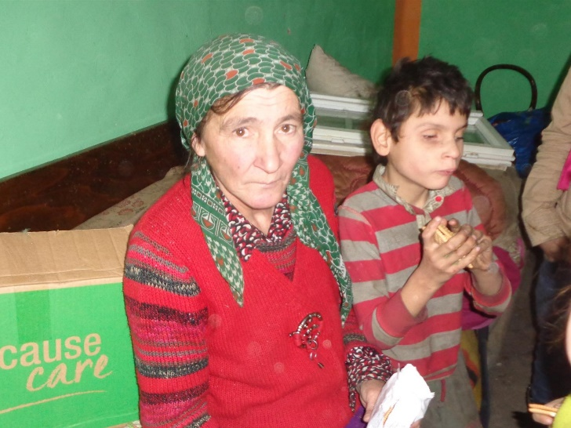
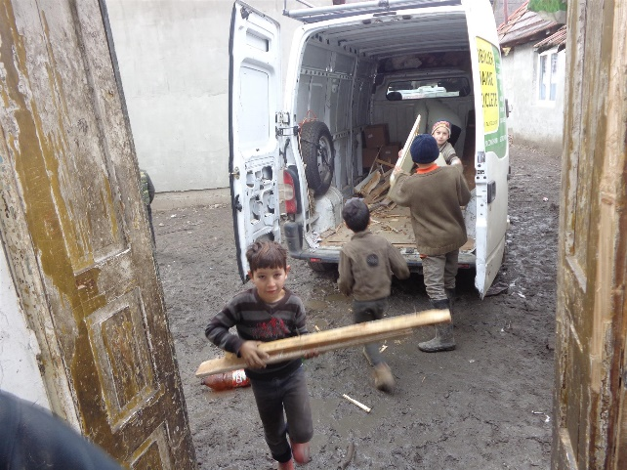
Kati writes: ‘In November we helped Gabi and his mother with wood and furniture. The wood was a big help for them and a part of the furniture, as agreed, was sold to get money for food. His Mum ask me if we could help them with paint. So we donate to them with a condition: “next month when I come the room will be painted”. In December I have a big surprise, the room was refreshed and painted in green and orange. The colour! My husband heard that somebody had some house demolition material in a near village. The wood was dry and good for firewood. I think I never saw her so happy. She told me that will be enough for almost 3 weeks, and this is a big Christmas help for them. I was surprised because I was expecting that she will ask me for something more. But no. For the first time I feel the joy and peace in this house. This was a miracle for me…..but God give more for us. Gabi always call me “tanti” but she corrected him “doamna (lady)” Gabi pronounced clearly “doamna” Than I ask him “Gabi You start to speak Romanian?” And he answered:” I try to speak”. GABI start to Speak!!! What a miracle. Christmas Miracle! Then I ask him if he want biscuits? He said “Da” Yes! I have tears in my eyes! To be honest I would never think this was possible. But thanks to God, and through your prayers God is working!
Gabi and his mum
Unloading the firewood.

Prayer Points:
- For complete healing for Gabi’s mother
- For ‘Sandra’as she settles into Dorcas House. For wisdom and understanding for the staff as they increasiingly realise her needs.
- For someone to lead the Life Skills/ Education/creative Arts progamme for the children at the local institution.
- Thank God for answered prayer, progress made, and relationships deepened.

On behalf of..... Have a Blessed Easter.

